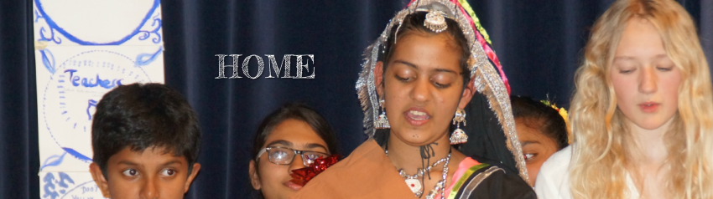

Theatre project 2016-2017
http://eumindtheatre4.weebly.com

International jury
Critera to assess the articles
Best articles will be awarded with a certificate of excellence
General lay-out of articles  Use of various features of Weebly: 10 p.  Use of pictures, colours etc. | 20
Stage one  Presentation of group: text, pictures, originality | 10
Stage one  Action plan  Clear description of the tasks | 5
Stage two: steps 1, 2, 3, 4  Research (about 300 words)  Findings:  - Research on own ‘national folktales related to Aesopus: 10 p.  - Short summary of one or more folktales: 10 p. | 20
Stage two: step 5  Create a simple story per group (and therefore per theme)  - Quality of the story. To which extent have ‘Tips for writing own fables’ been applied on own story? 10 p.  - Is there a clear moral? 5 p. | 15
Stage three  Script based upon the story of the counterparts (if possible) or based on own story. Create a short play and film it  Quality of the script. Title, characters, main topic /theme, moral: 20 p.  Quality of the film: 10 p (+ 10 extra) | 30
Total | 100
Bonus  Evidence of interaction and communication between groups  Other excellent features, upon the jury to decide | 10
No certificates of excellence will be given if stage three is not published by February 7th 2016

